**Title Title Title Title Title**

**Title Title**

Type of Thesis

(e.g. Diploma Thesis, Bachelor Thesis, Master Thesis,…)

Primary Supervisor: Prof. Dr. Martin Hepp

Universität der Bundeswehr München

Chair of General Management and E-Business

Co-Supervisor: Prof. Dr. XYZ

Universität der Bundeswehr München

Chair of XYZ

Submitted by <**given name> <family name>**

Student ID: 012345

Werner-Heisenberg-Weg 39

85579 Neubiberg

*[Empty Page]*

Table of Contents

Index of Figures 4

Index of Tables 5

Index of Abbreviations 6

1 Headline Top Level 7

1.1 Headline Level 2 7

1.1.1 Headline Level 3 7

Appendix 10

Bibliography 11

*[****IMPORTANT****: Font size is* ***10****; small right margin;* ***No*** *dot after top-level headline;* ***No*** *tab stops in the table of contents!]*

# List of Figures

Figure 1: Example 9

*[****IMPORTANT****: This index is generated automatically, if you paste the figure title in the text with Right Click🡪Insert Label]*

# List of Tables

Table 1: Example 9

*[****IMPORTANT:*** *Inserting label of a table in the text with Right Click🡪Insert Label]*

# List of Abbreviations

UniBw = Universität der Bundeswehr

WOW = Wirtschafts- und Organisationswissenschaften

# Headline Top Level

*[****IMPORTANT:*** *No dot after top-level headline!]*

## Headline Level 2

### Headline Level 3

OWL provides three increasingly expressive sublanguages designed for use by specific communities of implementers and users.

OWL Lite supports those users primarily needing a classification hierarchy and simple constraints. For example, while it supports cardinality constraints, it only permits cardinality values of 0 or 1. It should be simpler to provide tool support for OWL Lite than its more expressive relatives, and OWL Lite provides a quick migration path for thesauri and other taxonomies. Owl Lite also has a lower formal complexity than OWL DL, see the section on OWL Lite in the OWL Reference for further details.

OWL DL supports those users who want the maximum expressiveness while retaining computational completeness (all conclusions are guaranteed to be computable) and decidability (all computations will finish in finite time). OWL DL includes all OWL language constructs, but they can be used only under certain restrictions (for example, while a class may be a subclass of many classes, a class cannot be an instance of another class). OWL DL is so named due to its correspondence with description logics, a field of research that has studied the logics that form the formal foundation of OWL.

OWL Full is meant for users who want maximum expressiveness and the syntactic freedom of RDF with no computational guarantees. For example, in OWL Full a class can be treated simultaneously as a collection of individuals and as an individual in its own right. OWL Full allows an ontology to augment the meaning of the pre-defined (RDF or OWL) vocabulary. It is unlikely that any reasoning software will be able to support complete reasoning for every feature of OWL Full.

Each of these sublanguages is an extension of its simpler predecessor, both in what can be legally expressed and in what can be validly concluded. The following set of relations hold. Their inverses do not.

* Every legal OWL Lite ontology is a legal OWL DL ontology.
* Every legal OWL DL ontology is a legal OWL Full ontology.
* Every valid OWL Lite conclusion is a valid OWL DL conclusion.
* Every valid OWL DL conclusion is a valid OWL Full conclusion.
  + ABC
  + XYZ

*[****IMPORTANT:*** *Always use bullet-points like above (dt. “Spiegelstriche”), no matter which level!]*

Ontology developers adopting OWL should consider which sublanguage best suits their needs. The choice between OWL Lite and OWL DL depends on the extent to which users require the more-expressive constructs provided by OWL DL. The choice between OWL DL and OWL Full mainly depends on the extent to which users require the meta-modeling facilities of RDF Schema (e.g. defining classes of classes, or attaching properties to classes). When using OWL Full as compared to OWL DL, reasoning support is less predictable since complete OWL Full implementations do not currently exist.

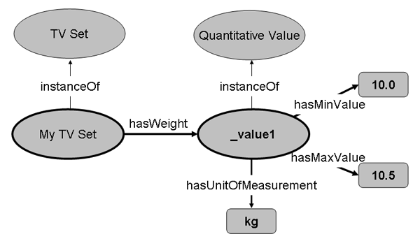

Figure 1: Example

|  |  |  |  |
| --- | --- | --- | --- |
| Tabelle 1 | A | B | c |
| x | ax | bx | cx |
| y | ay | by | cy |

Table 1: Example

# Appendix / Appendices

# References

*[Empty Page]*

I declare that this document and the accompanying code has been composed by myself, and describes my own work, unless otherwise acknowledged in the text. It has not been accepted in any previous application for a degree. All verbatim extracts have been distinguished by quotation marks, and all sources of information have been specifically acknowledged. Furthermore I took note of the bulletin concerning the usage of thesis. I hereby grant the Universität der Bundeswehr München permission to use the thesis for teaching and research purposes*.

*Please delete if inapplicable.

………………………………………………………………..

(Signature of the author/s)